POWER SPECTRAL DENSITY (PSD) ANALYSIS OF PHASE MODULATED (PM) SIGNALS USING MATLAB
Objectives
i) To generate a Phase Modulated (PM) signal in MATLAB using specified carrier and message signal parameters.
ii) To compute the frequency spectrum of the PM signal using the Fast Fourier Transform (FFT). iii) To calculate and plot the Power Spectral Density (PSD) of the PM signal using MATLAB. iv) To identify the carrier component and sideband frequencies present in the PM spectrum. v) To analyze the effect of phase modulation on the spectral distribution and bandwidth of the transmitted signal.
vi)To investigate the influence of modulation index on the Power Spectral Density characteristics of the PM signal.
PROGRAM (MATLAB CODE)
clc;
clear;
close all;
% Parameters
Am = 1; % Message Amplitude (V)
fm = 100; % Message Frequency (Hz)
Ac = 5; % Carrier Amplitude (V)
fc = 1000; % Carrier Frequency (Hz)
fs = 20*fc; % Sampling Frequency (Hz)
kp = pi/2; % Phase Sensitivity (rad/V)
% Time Vector
t = 0:1/fs:4/fm;
% Message Signal
m = Am*sin(2*pi*fm*t);
% PM Signal
pm = Ac*cos(2*pi*fc*t + kp*m);
% Phase Deviation
beta = kp*Am;
% FFT
N = length(pm);
f = linspace(-fs/2,fs/2,N);
PM_FFT = abs(fftshift(fft(pm)))/N;
% Power Spectral Density
PSD = (abs(fftshift(fft(pm))).^2)/(N*fs);
% Approximate Bandwidth
BW = 2*(beta+1)*fm;
fprintf('Phase Deviation = %.2f radians\n',beta);
fprintf('Estimated Bandwidth = %.2f Hz\n',BW);
% Plotting
figure('Name','PSD Analysis of PM Signal','NumberTitle','off'); subplot(2,2,1);
plot(t,m);
title('Message Signal');
xlabel('Time (s)');
ylabel('Amplitude');
grid on;
subplot(2,2,2);
plot(t,pm);
title('Phase Modulated Signal');
xlabel('Time (s)');
ylabel('Amplitude');
grid on;
subplot(2,2,3);
plot(f,PM_FFT);
title('Frequency Spectrum of PM Signal');
xlabel('Frequency (Hz)');
ylabel('Magnitude');
grid on;
subplot(2,2,4);
plot(f,PSD);
title('Power Spectral Density');
xlabel('Frequency (Hz)');
ylabel('PSD');
grid on;
OUTPUT:
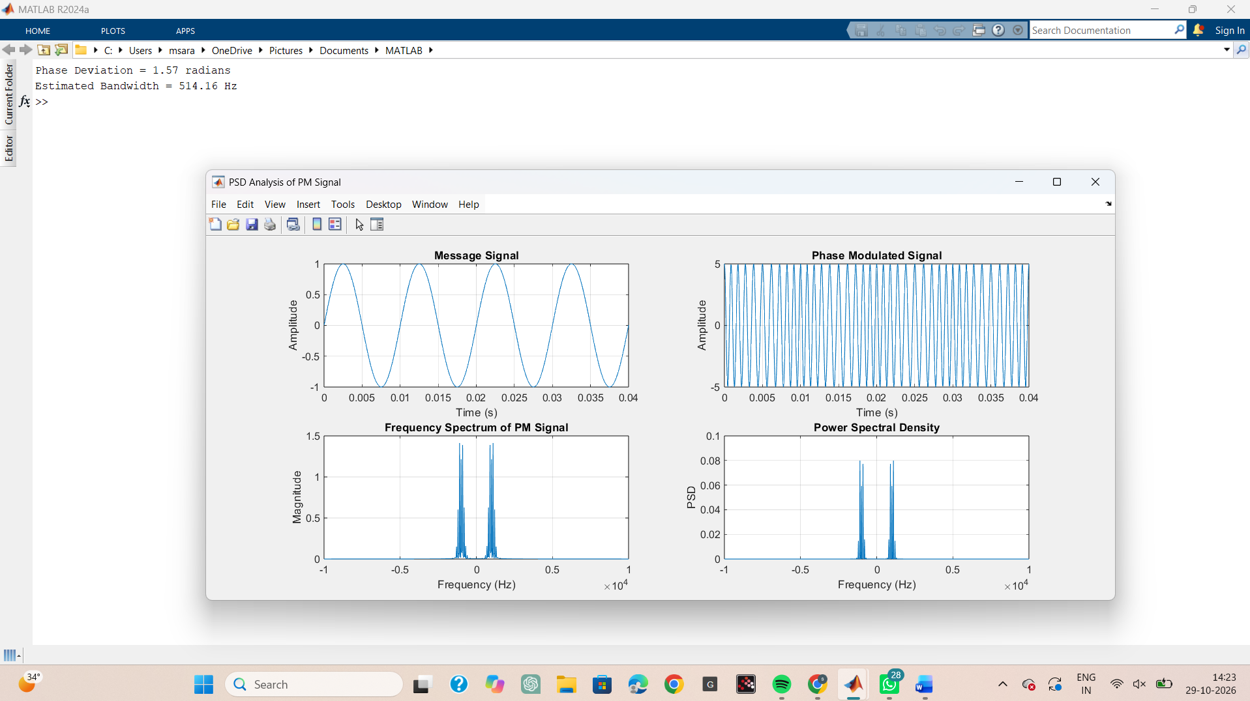

RESULT
The Power Spectral Density (PSD) of the Phase Modulated (PM) signal was successfully obtained and analyzed using MATLAB.
i) Message Frequency = 100 Hz
ii) Carrier Frequency = 1000 Hz
iii) Phase Deviation = 1.57 radians
iv) PM Modulation Index = 1.57
v) Estimated Bandwidth = 514 Hz
vi) The PSD plot showed the carrier component and multiple sidebands around the carrier frequency, confirming the frequency-domain characteristics of Phase Modulation.

